***Secure Data with OpenSSL: Key Generation and Message Encryption***

**First and Second Step**

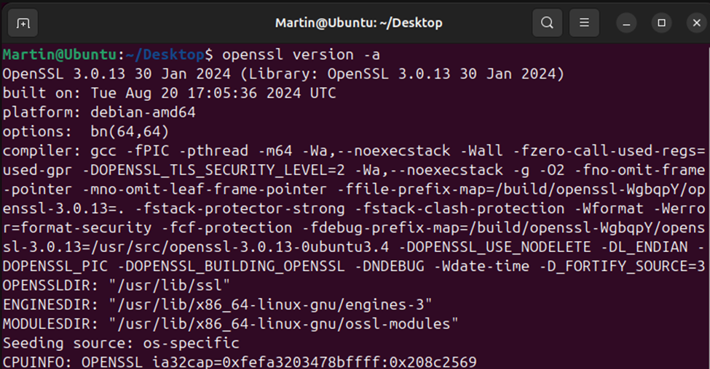

**Third and Fourth Step**

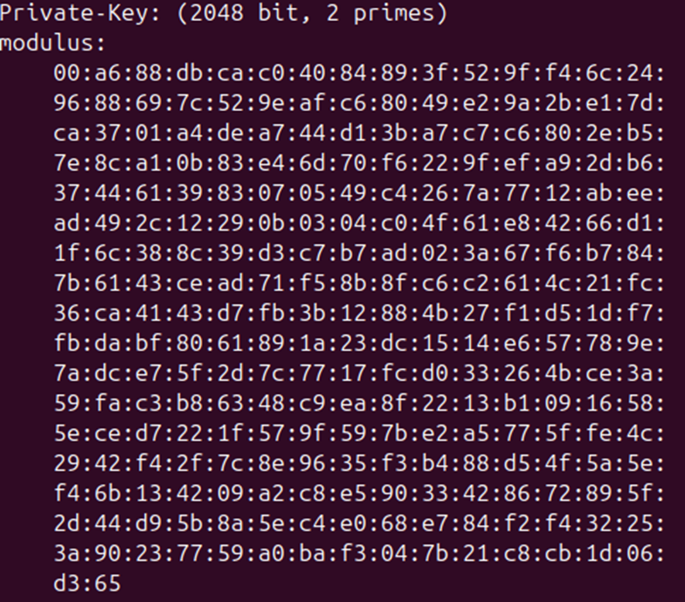

**Fifth Step**



**Sixth Step**

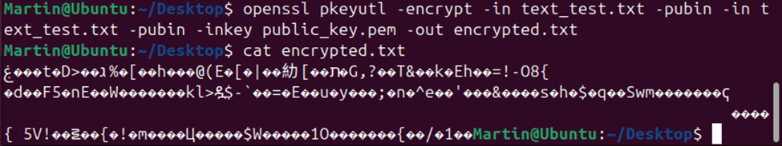

**Seventh and Eigth Step**

